**VIVEKANAND EDUCATION SOCIETY’S INSTITUTE OF TECHNOLOGY**

**(An Autonomous Institute Affiliated to University of Mumbai)**

**Department of Computer Engineering**



Project Report on

Smart Travel Itinerary

Submitted in partial fulfillment of the requirements of the degree

**BACHELOR OF ENGINEERING IN** **COMPUTER ENGINEERING**

By

**Riddhi Labde/26**

**Priti Shamnani/53**

**Neha Valecha/64**

**Project Mentor**

Mrs.Pallavi Gangurde

**University of Mumbai**

**(AY 2023-24)**

**VIVEKANAND EDUCATION SOCIETY’S INSTITUTE OF TECHNOLOGY**

**(An Autonomous Institute Affiliated to University of Mumbai)**

**Department of Computer Engineering**



# CERTIFICATE

This is to certify that the Mini Project entitled **“Smart Travel Itinerary ”** is a bonafide work of **Riddhi Labde(26), Priti Shamnani(53), Neha Valecha(64)** submitted to the University of Mumbai in partial fulfillment of the requirement for the award of the degree of **“Bachelor of Engineering”** in **“Computer Engineering” .**

## (Prof.Pallavi Gangurde)

Mentor

## (Dr. Nupur Giri) (Dr. J.M.Nair)

Head of Department Principal

# Mini Project Approval

This Mini Project entitled “ **Smart Travel Itinerary”** by **Priti Shamnani (53), Riddhi Labde (26), Neha Valecha (64)** is approved for the degree of **Bachelor of Engineering** in **Computer Engineering.**

**Examiners**

**1………………………………………**

(Internal Examiner Name & Sign)

## 2…………………………………………

(External Examiner name & Sign)

Date:

Place:

# 

**Declaration**

We declare that this written submission represents our ideas in our own words and where others' ideas or words have been included, we have adequately cited and referenced the original sources. We also declare that we have adhered to all principles of academic honesty and integrity and have not misrepresented or fabricated or falsified any idea/data/fact/source in our submission. We understand that any violation of the above will be cause for disciplinary action by the Institute and can also evoke penal action from the sources which have thus not been properly cited or from whom proper permission has not been taken when needed.

| -----------------------------------------  Riddhi Labde - 26 | -----------------------------------------  Priti Shamnani - 53 |  |
| --- | --- | --- |
| -----------------------------------------  Neha Valecha - 64 |  |  |
|  |  |  |

Date:

# 

# 

# 

# 

# 

**ACKNOWLEDGEMENT**

We are thankful to our college Vivekanand Education Society’s Institute of Technology for considering our project and extending help at all stages needed during our work of collecting information regarding the project.

It gives us immense pleasure to express our deep and sincere gratitude to Assistant Professor **Mrs. Pallavi Gangurde** for her kind help and valuable advice during the development of project synopsis and for her guidance and suggestions.

We are deeply indebted to Head of the Computer Department **Dr.(Mrs.) Nupur Giri** and our Principal **Dr. (Mrs.) J.M. Nair ,** for giving us this valuable opportunity to do this project.

We express our hearty thanks to them for their assistance without which it would have been difficult in finishing this project synopsis and project review successfully.

We convey our deep sense of gratitude to all teaching and non-teaching staff for their constant encouragement, support and selfless help throughout the project work. It is a great pleasure to acknowledge the help and suggestion, which we received from the Department of Computer Engineering.

We wish to express our profound thanks to all those who helped us in gathering information about the project. Our families too have provided moral support and encouragement several times.

**Contents**

**Abstract 1**

**Chapter 1: Introduction 2**

1.1 Introduction 2

1.2 Motivation 2

1.3 Problem Definition 2

1.4 Existing Systems 3

1.5 Lacuna of the existing systems 3

1.6 Relevance of the Project 4

**Chapter 2: Literature Survey** **5**

A. Brief Overview of Literature Survey 5

B. Related Works 5

2.1 Research Papers Referred 5

a. Abstract of the research paper

b. Inference drawn

2.2 Comparison with the existing system 7

**Chapter 3: Requirement Gathering for the Proposed System 8**

3.1 Introduction to requirement gathering 8

3.2 Functional Requirements 8

3.3 Non-Functional Requirements 9

3.4.Hardware, Software , Technology and tools utilized 10

3.5 Constraints 11

**Chapter** 4**: Proposed Design 13**

4.1 Block diagram of the system 13

4.2 Sequence diagram of the system 13

4.3 Project Scheduling & Tracking using Timeline / Gantt Chart 14

**Chapter 5: Implementation of the Proposed System 15**

5.1. Methodology employed for development 15

5.2 Algorithms and flowcharts for the respective modules developed 16

5.3 Datasets source and utilization 19

**Chapter 6: Testing of the Proposed System 20**

6.1. Introduction to testing 20

6.2. Types of tests Considered 20

6.3 Various test case scenarios considered 20

6.4. Inference drawn from the test cases 21

**Chapter 7: Results and Discussion 22**

7.1. Screenshots of User Interface (UI) for the respective module 22

7.2. Performance Evaluation measures 24

7.3. Input Parameters / Features considered 25

7.4. Inference drawn 26

**Chapter 8: Conclusion 27**

8.1 Limitations 27

8.2 Conclusion 27

8.3 Future Scope 28

**References 29**

**Appendix 30**

**1. Research Paper Details 30**

a. Paper published 30

b. Plagiarism report 31

c. Project review sheet 32

## 

## 

## 

## 

## List of Figures

| **Figure.no** | **Figures** | **Page.no** |
| --- | --- | --- |
| 4.1.1 | Block Diagram of Smart Travel Itinerary System | 13 |
| 4.2.1 | Sequence Diagram of Smart Travel Itinerary System | 13 |
| 4.3.1 | Gantt Chart | 14 |
| 5.2.1 | User Validation | 16 |
| 5.2.2 | Preference Form | 16 |
| 5.2.3 | Itinerary Generation | 17 |
| 5.2.4 | Booking | 18 |
| 5.2.5 | Recommendation System | 19 |
| 6.4.1 | Selenium Testing performed on the system | 20 |
| 7.1.1 | Home Page | 22 |
| 7.1.2 | Login page | 22 |
| 7.1.3 | Registration Page | 22 |
| 7.1.4 | Weather Forecast | 23 |
| 7.1.5 | Itinerary Generator | 23 |
| 7.1.6 | Flight and Hotel Booking | 24 |
| 7.1.7 | Recommendation | 24 |

**ABSTRACT**

Planning your dream trip just got a whole lot simpler with our Smart Travel Itinerary! Imagine having a savvy travel buddy who not only crafts your perfect itinerary but also keeps an eye on the weather and suggests exciting tourist packages.

Here’s the scoop: Our system is like a travel genius that understands your style, preferences, and how long you'll be away. It then whips up a tailor-made itinerary, packed with must-see sights, fun activities, and hidden gems.

But hold onto your hats! Our system doesn’t stop there. It checks the weather forecast to make sure your plans are weather-ready. Whether it's sunny skies or a bit of rain, we've got you covered.

And that’s not all! We've teamed up with top-notch tour operators to offer exclusive tourist packages. Whether you fancy city tours, outdoor adventures, or cultural experiences, we've got just the ticket for you.

To make your trip planning a breeze, we’ve cooked up an easy-to-use app. Just plug in your travel dates and preferences, and presto! Your personalized itinerary, complete with weather updates and tour options, is ready to roll.

So why stress over trip planning when you can have your very own Smart Travel Itinerary. Get set for an adventure-packed journey, hassle-free!

## 

## 

## 

## 

## 

## 

**Chapter 1 : Introduction**

**1.1 Introduction**

When you're tired of your usual routine, a vacation can be a refreshing change. But planning one can be a real hassle these days. You have to spend a lot of time looking up hotels, places to visit, and how to get around. It can feel like a big chore. That's where our project comes in to help!

Our goal is to make vacation planning a lot easier for you. We create a travel plan that's based on what you like and what you want to do. Instead of spending hours searching online, you just tell us a few things.where you want to go, when you'll be going, what kind of trip you want, and what kind of hotels you prefer. With this information, we'll put together a plan that covers everything.

Imagine having a roadmap for your whole trip – the best way to get from one place to another, the coolest things to see, and even where to eat. It's like having a personal travel guide who knows all the best spots.

We want to take away the stress of planning so you can enjoy your vacation. We'll make sure you don't miss out on anything exciting and help you make the most of your time. So, instead of worrying about all the details, you can focus on having a great time and exploring new places.

**1.2 Motivation**

* **Affordable Travel Planning Access:** The project aims to make tailored travel planning accessible to everyone, bridging the gap between those who can afford personalized travel advisors and those who cannot.
* **Simplified Travel Planning:** By simplifying the complex process of travel planning, the project provides a one-stop solution, reducing stress and making travel planning more enjoyable**.**
* **Flexible Solutions:** ItinAIgenius offers flexibility for different traveler needs, whether for leisure, adventure, relaxation, or cultural exploration.
* **Financial Accessibility:** It alleviates the financial burden of expensive travel advisors, making customized travel planning affordable for a wider range of travelers.

**1.3 Problem Definition**

The travel and tourism industry is rapidly evolving, with travelers seeking more personalized and efficient experiences. Traditional travel planning can be cumbersome and overwhelming, often resulting in suboptimal itineraries. To address these challenges, "Smart Travel itinerary" aims to provide a solution that streamlines the travel planning process, offers personalized recommendations, and enhances overall travel experiences.

* **Efficient Travel Planning:** Develop a user-friendly platform that simplifies trip planning, considering factors such as preferences, interests, and constraints (e.g., budget, time). Integration of Google Maps API and TripAdvisor API will provide users with accurate information and recommendations.
* **Personalization:** Implement AI-driven algorithms to tailor itineraries based on individual preferences, including cultural interests, food preferences, and activity levels. This personalization ensures that each traveler receives recommendations tailored to their unique preferences and tastes.
* **Recommendation Engine**: Create a robust recommendation system that suggests destinations, attractions, accommodations, and activities based on user profiles and historical data. By leveraging TripAdvisor API, users can access comprehensive reviews and ratings to make informed decisions.
* **Weather Forecasting:** Develop a dedicated weather page where users can input their starting and ending dates to receive accurate weather forecasts for their destination. By integrating weather data into itinerary planning, travelers can make informed decisions and prepare accordingly for their trip.

**1.4 Existing System**

Traditional Travel Planning Methods:

Traditional travel planning typically involves a manual process where travelers rely on a combination of guidebooks, online research, and personal recommendations to plan their trips. This process often lacks personalization and can be time-consuming and overwhelming for users, especially when visiting unfamiliar destinations. Some common drawbacks of traditional travel planning methods include:

* **Limited Personalization:** Traditional travel planning methods often provide generic recommendations and lack personalization tailored to the specific preferences and interests of individual travelers.Information Overload: Travelers are often inundated with vast amounts of information from various sources, making it challenging to filter and prioritize relevant details for their trip.
* **Static Recommendations:** Guidebooks and online resources may offer static recommendations that do not consider real-time factors such as current weather conditions, local events, or changes in business operations.
* **Manual Data Entry:** Users typically need to manually input their preferences, travel dates, and destination information into planning tools, which can be tedious and time-consuming.
* **Limited Integration:** Existing travel planning systems may lack integration with other services, such as weather forecasts, real-time location data, or personalized recommendations, leading to a fragmented user experience.

**1.5 Lacuna of the existing system**

Potential lacunae in existing systems that your project aims to address:

* Static Recommendations: Guidebooks, online travel forums, and recommendation websites typically offer static recommendations that may become outdated or fail to reflect real-time factors such as weather conditions, local events, or changes in business operations.
* Fragmented Information Sources: Travelers often need to consult multiple sources of information, such as guidebooks, websites, and social media platforms, to gather relevant details for their trip.
* Manual Data Entry: Users are often required to manually input their preferences, travel dates, and destination information into planning tools, which can be time-consuming and error-prone. Additionally, manually updating itinerary details or adjusting plans in response to changes can be cumbersome and inefficient.
* Lack of Integration with Real-time Data: Existing travel planning systems may lack integration with real-time data sources such as weather forecasts, traffic updates, or event schedules. This limits their ability to provide timely and relevant information to users and adapt recommendations based on changing circumstances.
* Limited Optimization: Traditional travel planning methods may not leverage optimization techniques or AI-driven algorithms to generate efficient and customized travel itineraries. As a result, users may miss out on opportunities to maximize their travel experience, optimize their time and budget, or discover hidden gems.

**1.6 Relevance of the project**

The relevance of your smart travel itinerary project lies in its ability to address contemporary challenges and meet the evolving needs of modern travelers. Some key points highlighting the relevance of the project:

* Personalization: In an era where personalization is increasingly valued, your project offers travelers tailored recommendations and itineraries based on their preferences, interests, and constraints. This relevance aligns with the growing demand for customized experiences in various industries, including travel and tourism.
* Efficiency: With the proliferation of technology, travelers expect streamlined processes and efficient solutions. Your project optimizes the travel planning process by automating tasks, leveraging AI algorithms for itinerary generation, and integrating real-time data to enhance decision-making. This efficiency resonates with the desire for convenience and time-saving solutions among modern travelers.
* Data-driven Insights: By harnessing AI and data analytics, your project provides valuable insights into user behavior, preferences, and trends in travel patterns. These insights not only enhance the user experience but also enable businesses in the travel industry to better understand their customers and tailor their services accordingly.
* Adaptability: The inclusion of real-time data sources such as weather forecasts and location-based services enables your project to adapt recommendations and itineraries dynamically, reflecting changing circumstances and enhancing user satisfaction. This adaptability aligns with the need for flexibility and responsiveness in today's fast-paced world.
* Competitive Advantage: As travelers seek innovative solutions that cater to their individual needs and preferences, your project positions itself as a competitive offering in the travel technology market. By providing a unique value proposition through AI-driven personalization and real-time data integration, your project stands out among traditional travel planning methods and existing digital solutions.

**Chapter 2 : Literature Survey**

**A. Brief Overview of Literature Survey:**

The literature survey encompasses a wide range of studies on AI applications within the context of travel itinerary planning and recommendation systems. Some studies delve into practical implementations, such as AI-driven itinerary generators and personalized recommendation algorithms, while others explore broader concepts like user preferences analysis and route optimization. However, a recurring theme across these papers is the pressing need for further research to address challenges related to data accuracy, user privacy, and seamless integration with existing travel platforms. While acknowledging the transformative potential of AI in revolutionizing travel planning, the literature emphasizes the importance of bridging the gap between theoretical advancements and practical implementations to ensure tangible benefits for end-users in the travel industry.

**B. Related Works**

As a part of the literature survey we have reviewed papers on various aspects of AI related to tourism.

**2.1 Research Papers Referred**

**1. Itinerary Recommender System with Semantic Trajectory Pattern Mining from Geo-tagged Photos**

**Abstract-**  They mine people's movements from geo-tagged photos, but face privacy concerns. To broaden its reach, an expansion is proposed, encompassing more global destinations and languages. This expansion aims to enhance inclusivity while addressing privacy worries, ensuring users from diverse backgrounds can benefit from personalized recommendations with confidence in their data privacy.[1]

**Inference-** The proposed expansion of the "Itinerary Recommender System with Semantic Trajectory Pattern Mining from Geo-tagged Photos" highlights the intersection of technological advancement and privacy concerns. While leveraging geo-tagged data offers valuable insights into user behavior, ensuring privacy protection is essential for user trust and adoption. By expanding the system's coverage to include a wider range of destinations and languages, efforts are made to enhance inclusivity while addressing privacy concerns, ultimately aiming for a balance between personalized recommendations and user privacy in trajectory pattern mining applications.[1]

**2. Wanderlust: A Personalized Travel Itinerary Recommender**

**Abstract-** This paper introduces a topical package space model to bridge the gap between optimized travel routes and user preferences. By integrating hashtags, travel cost spread, and time of travel for each point of interest, the system enhances itinerary recommendations. To combat limited creativity inherent in recommender systems, the project engages users in defining their eating preferences, enabling personalized suggestions for restaurants near each point of interest.[2]

**Inference-** The utilization of a topical package space model in "Wanderlust: A Personalized Travel Itinerary Recommender" underscores the project's commitment to optimizing travel routes while catering to individual user interests. By incorporating factors such as hashtags, travel cost spread, and time of travel for each point of interest, the system offers tailored itinerary recommendations. Moreover, by addressing the issue of limited creativity in recommender systems through user engagement regarding eating preferences, the project seeks to enhance travel experiences by facilitating the discovery of unconventional attractions and dining options, thereby fostering more memorable and personalized journeys for users.[2]

**3. The Smart Travel Itinerary Planner**

**Abstract-** This paper employs a methodology that aggregates URLs from popular travel platforms like TripAdvisor and Holidify to gather information about tourist attractions and reviews. This data is utilized to create personalized travel itineraries for users. However, challenges arise in maintaining the system's relevance with the latest travel trends and information, along with limitations in geographic coverage, particularly for less-visited or remote destinations. To enhance user engagement and potentially commercialize the platform, a proposed module allows users to submit their trip blogs and vlogs, thereby enriching the content and expanding the platform's utility.[3]

**Inference-** The Smart Travel Itinerary Planner offers a promising solution for generating personalized travel itineraries by aggregating data from popular travel platforms. However, its effectiveness may be hindered by the challenges of staying updated with evolving travel trends and maintaining comprehensive coverage, especially for less-visited destinations. The proposed module for user-generated trip content presents an opportunity for increased engagement and commercialization but also introduces potential challenges related to content moderation and quality control. Overall, while the system shows potential, its long-term success hinges on addressing these limitations effectively.[3]

**4. The multi-agent system for itinerary suggestion in smart environment**

**Abstract-** This paper utilizes a Multi-Armed Bandit problem to establish associations between user groups and itineraries. Despite its effectiveness, the system operates under simplified assumptions that may not fully capture the complexity of real-world travel scenarios, and scalability concerns arise when handling a large number of simultaneous users. To enhance the system's performance, proposed enhancements include deploying it in real-world Points of Interest (POIs), incorporating additional smartphone sensors to capture diverse onsite travel behaviors accurately, and integrating real-time congestion information for more informed travel route recommendations. These improvements aim to refine itinerary suggestions and elevate tourists' travel experiences.[4]

**Inference-** The multi-agent system represents an innovative approach to itinerary suggestion, leveraging algorithms to optimize itinerary recommendations. However, the system's reliance on simplified assumptions and scalability limitations underscores the need for ongoing enhancements to better align with real-world travel dynamics and accommodate larger user bases. By incorporating real-time data and deploying in actual Points of Interest.[4]

**5. The task-oriented Smart Tourism Chatbot Service**

**Abstract-** This paper operates within a smart tourism platform, comprising both the chatbot and information systems. Utilizing an information knowledgebase, the chatbot identifies user intentions and retrieves relevant tourism information. However, limitations may arise concerning integration with other platforms or services, potentially hindering seamless assistance in booking accommodations, transportation, or activities. To address this, there are plans to expand the chatbot service to provide tourism information QA services via smart tourism platforms and mobile apps.[5]

**Inference-** The task-oriented Smart Tourism Chatbot Service represents an efficient means of providing tourism information to users within a smart tourism framework. However, the system's current limitations in seamless integration with other services highlight the need for further development to enhance its functionality, particularly in facilitating bookings and providing comprehensive tourism information services. By expanding its capabilities to include QA services across multiple platforms and mobile apps, the chatbot service can become more versatile and user-friendly, ultimately improving the overall tourism experience for users.[5]

**2.2 Comparison with Existing Systems:**

The project effectively delivers personalized travel itineraries and recommendations to users, significantly improving their travel planning experience and overall satisfaction compared to traditional manual itinerary planning methods.

Users find the interface intuitive and user-friendly, making it easy to input their preferences and customize their travel plans according to their needs, which may not be possible with existing static travel itinerary platforms.

Integration of real-time data sources, such as location-based services for nearby resources and weather prediction APIs, ensures that users receive accurate and up-to-date information for their travel destinations, offering a level of dynamism and responsiveness that may be lacking in conventional travel planning tools.

The Smart Travel Itinerary Project demonstrates superior performance compared to existing systems in terms of accuracy, responsiveness, and personalized recommendations, thereby setting a new standard for modern travel itinerary planning solutions.

**Chapter 3: Requirement Gathering**

**3.1 Introduction to requirement gathering**

In the development journey of our Smart Travel Itinerary project, requirement gathering stands as a cornerstone, essential for crafting a solution that redefines the way travelers plan and experience their journeys. Through a meticulous process of identifying, documenting, and prioritizing stakeholders' needs and expectations, we lay the groundwork for a software solution that not only meets but exceeds their requirements. By engaging a diverse range of stakeholders including travelers, travel agencies, destination management organizations, and technology partners, we gain valuable insights into the intricacies of travel planning. Techniques such as interviews, surveys, and focus groups allow us to delve deep into user preferences, pain points, and industry trends, shaping the design and functionality of our platform. Moreover, by integrating real-time data sources such as weather forecasts, traffic updates, and local events, we ensure that our travel itineraries remain adaptable to changing circumstances, providing users with timely and relevant recommendations. The meticulous documentation of requirements in clear, concise formats ensures accuracy, while regular validation and verification activities guarantee alignment with stakeholders' expectations and project scope. With a robust change management process in place, we maintain flexibility and agility, accommodating evolving needs and preferences throughout the project lifecycle. Ultimately, through collaborative efforts and a keen focus on user satisfaction, our Smart Travel Itinerary project aims to deliver personalized, efficient, and delightful travel experiences for all.

**3.2 Functional Requirements**

Functional requirements for Smart Travel Itinerary includes a variety of features and functionalities aimed at delivering a personalized, efficient, and engaging travel planning experience for users. Here are functional requirements:

User Authentication and Profile Management:

* Users will be able to register, login, and manage their profiles securely.
* Profile management functionalities includes updating personal information, preferences, and past travel history.

Itinerary Generation:

* Generate personalized travel itineraries based on user preferences, interests, constraints (such as budget, time, and mode of transportation), and destination characteristics.
* Incorporate AI-driven algorithms to optimize itineraries for maximum efficiency and enjoyment.
* Allow users to customize generated itineraries by adding or removing activities, adjusting schedules, and exploring alternative options.

Recommendation System:

* Provide recommendations for nearby attractions, restaurants, accommodations, and activities based on user preferences, location, and real-time data.
* Utilize collaborative filtering or content-based recommendation algorithms to suggest relevant options.
* Allow users to filter recommendations based on specific criteria such as cuisine type, price range, ratings, and distance.

Real-time Data Integration:

* Integrate real-time data sources such as weather forecasts, traffic updates, and local events to enhance itinerary planning and adaptability.
* Display current weather conditions and forecasts for destination locations.
* Alert users about traffic congestion, road closures, or other relevant travel advisories that may affect their plans.

Mapping and Navigation:

* Provide interactive maps with geolocation features to help users visualize their travel routes and destinations.
* Offer turn-by-turn navigation and directions to guide users to their planned activities and accommodations.
* Enable users to explore points of interest along their route and discover nearby attractions or amenities.

Booking and Reservation Integration:

* Allow users to book accommodations, transportation, and activities directly through the platform.
* Integrate with third-party booking systems or APIs to facilitate seamless reservations and payments.
* Provide confirmation details and itinerary updates in real-time.

Feedback and Review System:

* Enable users to rate and review destinations, accommodations, restaurants, and activities based on their experiences.
* Aggregate and display user-generated reviews to help inform other travelers' decisions.
* Allow users to provide feedback on the itinerary generation process and suggest improvements.

**3.3 Non-Functional Requirements**

Nonfunctional requirements describe the qualities or attributes that define how a system should behave, rather than specific functionalities. These requirements are essential for ensuring that the system meets user expectations in terms of performance, reliability, security, usability, and other aspects. Some nonfunctional requirements for Smart Travel Itinerary project:

Performance:

* The system should respond to user interactions promptly, with minimal latency.
* It should be capable of handling a large number of concurrent users without significant degradation in performance.
* Response times for itinerary generation, recommendation retrieval, and other critical functions should be within acceptable limits, even during peak usage periods.

Reliability:

* The system should be highly reliable and available, with minimal downtime.
* It should have mechanisms in place to prevent data loss and ensure data integrity.
* Backup and recovery procedures should be implemented to recover from unexpected failures or system crashes.

Scalability:

* The system should be designed to scale horizontally and vertically to accommodate increasing user demand and data volumes.
* It should support load balancing and auto-scaling capabilities to distribute workload efficiently across multiple servers or resources.

Security:

* The system should adhere to industry-standard security practices to protect user data and privacy.
* Secure authentication and authorization mechanisms should be implemented to prevent unauthorized access to sensitive information.
* Data transmission should be encrypted using secure protocols (e.g., SSL/TLS) to protect against interception and tampering.

Usability:

* The user interface should be intuitive, user-friendly, and accessible to users of all levels of technical proficiency.
* It should adhere to usability principles such as consistency, simplicity, and clarity in design.
* Support for multiple devices and screen sizes should be provided to ensure a seamless user experience across different platforms.

**3.4 Hardware, Software , Technology and tools utilized**

Hardware:

* Networking Equipment: Routers to facilitate network communication between clients and servers.
* Client Devices: Desktop computers, laptops, smartphones, and tablets used by travelers to access the application.

Software:

* Operating Systems: Windows
* Development Frameworks and Libraries:
  + MERN Stack (MongoDB, Express.js, React.js, Node.js) for building the frontend and backend components of the application.
  + Additional frontend libraries and frameworks such as Redux, Bootstrap, or Material-UI for enhancing user interface design and functionality.
* Database Management System: MongoDB for storing user data, itinerary details, preferences, and other relevant information.
* Web Servers: Apache HTTP Server for serving static assets and routing requests to the appropriate backend services.
* APIs and External Services: Integration with third-party APIs for accessing real-time data sources such as weather forecasts, mapping services, and booking platforms.
* Development Tools: Integrated development environments (IDEs) such as Visual Studio Code for coding and debugging.

Technologies:

* Artificial Intelligence and Machine Learning: Utilized for AI-driven itinerary generation, recommendation systems, and optimization algorithms.
* Geolocation Services: Integrating geolocation APIs (e.g., Google Maps API) for mapping and navigation functionalities.
* Real-time Data Integration: Incorporating APIs for accessing real-time weather forecasts, traffic updates, and event schedules.

Tools:

* Communication Tools: Slack, Microsoft Teams, or Discord for team communication and collaboration.
* Testing and Quality Assurance Tools: Selenium for automated testing, along with tools for load testing and performance monitoring.

**3.5 Constraints**

Constraints are factors that limit or restrict the development and implementation of a project. Identifying and addressing constraints is essential for managing expectations, allocating resources effectively, and ensuring the project's success. Here are some potential constraints for Smart Travel Itinerary project:

* Time Constraints: There may be deadlines or timeframes within which the project must be completed, such as launching before a certain travel season or meeting investor expectations. Adhering to strict timelines may require careful planning, prioritization of tasks, and efficient project management practices.
* Budgetary Constraints: The project may have budget limitations that dictate the allocation of resources, including funding for hardware, software licenses, development efforts, marketing, and ongoing maintenance. It's crucial to manage costs effectively and prioritize expenditures based on project priorities and objectives.
* Technological Constraints: The project may be constrained by the availability of specific technologies, tools, or platforms required for implementation. Compatibility issues, dependency on external APIs or services, and limitations of chosen frameworks or libraries may impact the project's development and functionality.
* Resource Constraints: Limited availability of skilled personnel, development teams, or subject matter experts may pose challenges to the project's execution. Identifying and addressing resource gaps through training, outsourcing, or collaboration with external partners may be necessary to overcome these constraints.
* Scope Constraints: The project scope defines the boundaries of what will be included in the final deliverable. Scope creep, or the uncontrolled expansion of project scope, can lead to delays, budget overruns, and stakeholder dissatisfaction. Managing scope effectively through clear requirements, change control processes, and regular communication with stakeholders is essential.

**Chapter 4: Proposed Design**

**4.1 Block Diagram of the system**

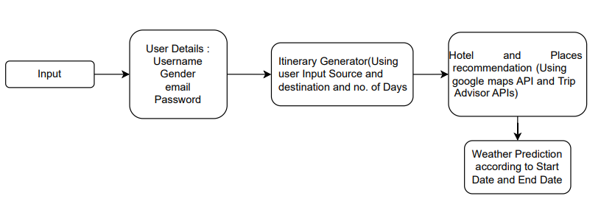

Fig 4.1.1 : Block Diagram of Smart Travel Itinerary System

This is the block diagram of the system which tells about how the system will work.The user input is scanned and based on that itinerary is generated and also places are recommended based on the user's location.

**4.2 Sequence Diagram of the system**

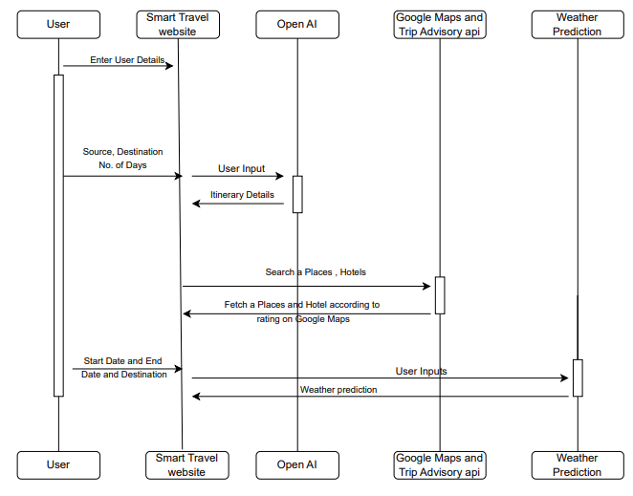

Fig 4.2.2 : Sequence Diagram of Smart Travel Itinerary System

This is the sequence diagram which tells in what sequence the system will run and also what is the expected output.The user is expected to input the number of days,budget,source and destination which is used for itinerary generation also for recommendation.

**4.3 Project Scheduling & Tracking using Timeline / Gantt Chart**

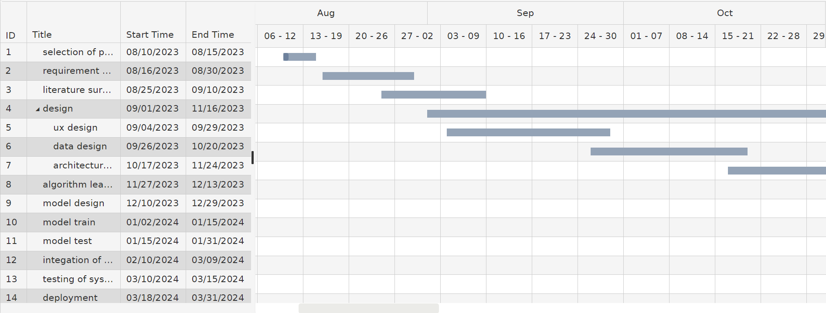

Fig 4.3.1 : Gantt Chart

This is the timeline for the project which indicates how the project was proceed.The gantt chart shows the start date of the project, also the end date and it is represented as the timeline, also how the project was developed and its start and end date.

**Chapter 5: Implementation of the Proposed System**

**5.1. Methodology employed for development**

The methodology employed for the development of our Smart Travel Itinerary project begins with

* User-Centered Design: The development process begins with extensive user research to understand travelers' preferences and needs. This research guides the design and development decisions throughout the project.
* Requirement Definition: Detailed requirements are meticulously documented, including travel dates, budget constraints, user interests, preferred destinations, and accessibility needs. These requirements serve as the blueprint for the development process.
* Destination Selection and Customization: The AI-driven system is designed to match user profiles with suitable destinations and allow customization of itineraries based on individual preferences and travel goals.
* Itinerary Generation: An AI-driven algorithm is implemented to generate personalized travel itineraries, optimizing routes and considering travel distances between destinations.
* Real-time Resource Integration: Integration with real-time data sources provides users with up-to-date information on nearby resources such as restaurants, accommodations, and attractions.
* User Interface Design: A user-friendly interface is developed, focusing on accessibility and ease of use. High-contrast design, legible text, and intuitive navigation elements enhance the user experience.
* Input and Preferences Gathering: An input form is implemented to collect travel preferences, enabling personalized itinerary recommendations based on user input.
* User Feedback Integration: A feedback system is created to allow users to review and customize generated itineraries, facilitating continuous improvement based on user input.
* Testing and Quality Assurance: Rigorous testing is conducted to ensure the accuracy of recommendations, evaluate usability, and address any issues before deployment.
* Deployment: The Smart Travel Itinerary application is deployed as a user-friendly web or mobile application, ensuring accessibility across different devices and platforms.
* Continuous Improvement: A feedback loop is established to monitor user feedback and make ongoing improvements to the AI models, data sources, and features for an enhanced travel planning experience.

**5.2. Algorithms and flowcharts for the respective modules developed**

1. User Input Collection Module Algorithm:

* User selects the "Login" is chosen, the system prompts the user to enter their email and password.
* The system validates the credentials.
* If the credentials are correct, the user is logged in and redirected to the main dashboard.
* If "Register" is chosen, the user provides necessary details such as email, password, and any additional information.
* The system creates a new user account.
* Upon successful registration, the user is logged in and redirected to the main dashboard.

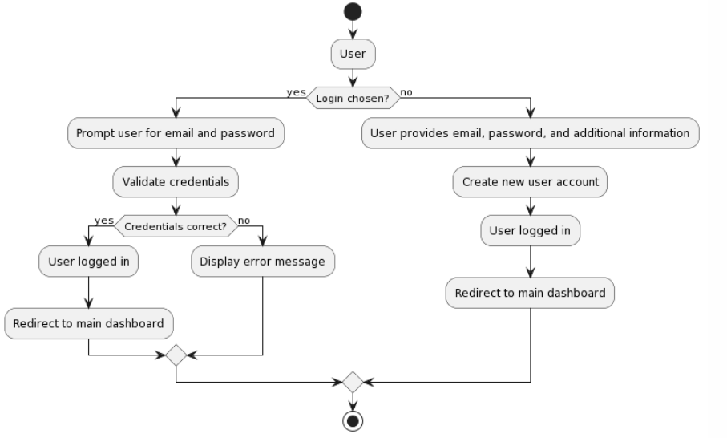

Fig 5.2.1 User Validation

2. Preference Form

* User Enters the detail in the preference form such as source, destination, budget, start date, end date
* The system checks for the input
* If the input is valid then the input is processed and uses the algorithm to generate itinerary
* If the input is invalid or missing fields then the message is displayed

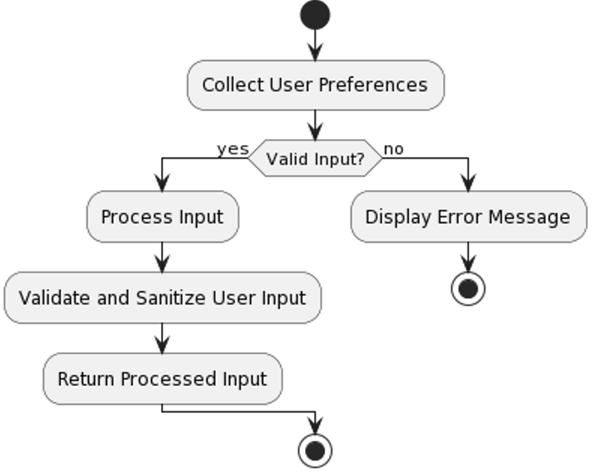

Fig 5.2.2 Preference form

3. Itinerary Generation Module Algorithm:

* Users provide input for trip preferences, including travel dates, budget, interests, and destination preferences.
* The system analyzes user input and matches it with suitable travel destinations.
* Based on the matched destinations and user preferences, the system generates a preliminary itinerary.
* The preliminary itinerary is optimized using algorithms to minimize travel time and maximize user satisfaction.
* Optimization factors include optimizing travel routes, considering distances between destinations, and accommodating user preferences.
* The optimized itinerary is presented to the user for review and customization.
* User feedback is captured and incorporated into the itinerary customization process.
* The itinerary is customized based on user feedback to meet individual preferences and requirements.
* The finalized itinerary is presented to the user for confirmation and acceptance.
* Upon user confirmation, the itinerary is saved and made available for further reference.

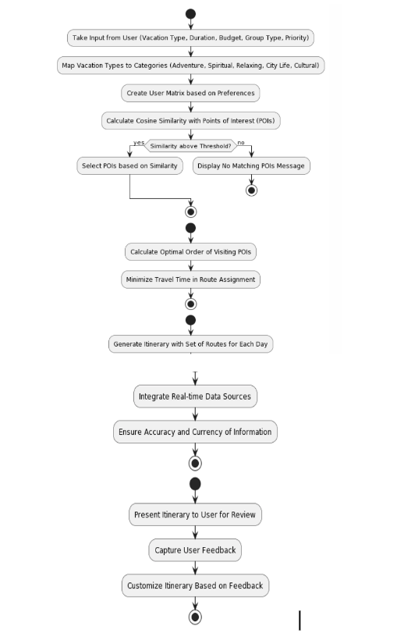

Fig 5.2.3 Itinerary Generation

4. Booking and Reservation Module Algorithm:

* User selects the desired accommodations, transportation, and activities from the generated itinerary.
* The system provides booking options for the selected accommodations, transportation, and activities.
* Users are presented with available booking options, including pricing and availability details.
* Secure transaction facilities are provided to ensure the safety of user transactions.
* Continuous monitoring of booking status, updates and feedback loop is conducted to ensure a seamless travel experience.
* Any changes or cancellations to bookings are handled through the system with appropriate notifications to the user.

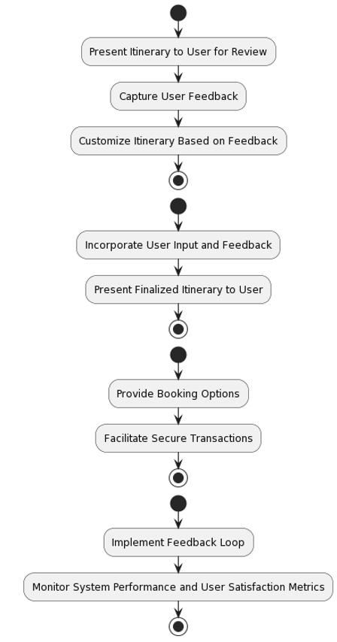

Fig 5.2.4 Booking

5. Recommendation System Module Algorithm:

* The system retrieves the user's current location using geolocation services or user input.
* Restaurants are filtered based on user preferences such as cuisine type, price range, and ratings.
* The system ranks the filtered restaurants either by their distance from the user's location or their ratings.
* The top-ranked restaurants are presented to the user as recommendations, along with relevant details such as name, address, and ratings.
* Similar steps are followed to recommend nearby attractions and hotels based on user preferences and location.
* The user can view and select recommended restaurants, attractions, and hotels.

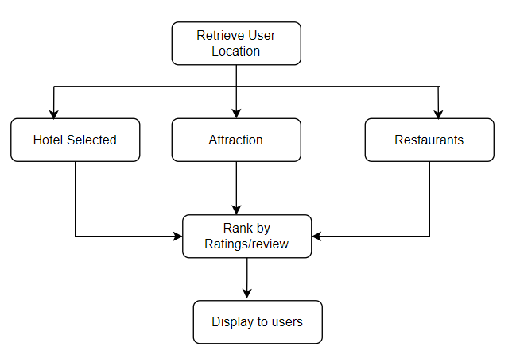

Fig 5.2.5 Recommendation System

**5.3. Datasets source and utilization**

The datasets used in the Smart Travel Itinerary Project were sourced from various reliable sources, including:

* OpenAI API for top recommendations.
* Google Maps API for itinerary generation and mapping.
* Kaggle datasets for training the TensorFlow model on tourist place detection.

The dataset was taken from Kaggle. Modules are as follows with more than hundreds of thousands of classification.

**Chapter 6: Testing of the Proposed System**

**6.1. Introduction to testing**

Testing is a crucial phase in the development lifecycle of the Smart Travel Itinerary Project. It ensures that the system functions as intended, meets user requirements, and delivers a seamless and satisfactory experience to tourists. Testing involves evaluating the system's functionalities, performance, reliability, and user interface across various scenarios and conditions.

**6.2. Types of tests Considered**

In the development of our Smart Travel Itinerary project, several types of tests were considered to ensure the quality and reliability of the application. These tests encompass various aspects of functionality, performance, usability, and security. Several types of tests were considered to comprehensively evaluate the proposed system:

* Unit Testing: Testing individual components and modules to verify their functionality in isolation.
* Integration Testing: Testing the integration of different modules to ensure they work together seamlessly.
* Functional Testing: Testing the system's functionality against specified requirements, including personalized recommendations, chatbot interactions, and itinerary generation.
* User Interface Testing: Evaluating the user interface for accessibility, responsiveness, and ease of use across different devices and platforms.
* Performance Testing: Assessing the system's performance under different load conditions to ensure responsiveness and stability.
* System Testing: Testing the entire system as a whole to verify that it meets the specified requirements and functions as intended.

**6.3 Various test case scenarios considered**

Several test case scenarios were considered to cover a wide range of user interactions and system functionalities:

* User Registration and Login: Testing the registration process and user authentication to ensure secure access to the system.
* Personalized Recommendation Testing: Evaluating the accuracy and relevance of personalized travel recommendations based on user preferences and historical data.
* Real-Time Data Integration Testing: Verifying the integration of real-time data sources for weather forecasts, local events, and accommodation availability using Booking.com
* Virtual Tour Testing: Testing the functionality of virtual tours using YouTube API to ensure smooth playback and immersive user experience.
* Itinerary Generation Testing: Evaluating the generation of personalized itineraries with Google Maps integration, including route recommendations and points of interest.

**6.4. Inference drawn from the test cases**

Based on the conducted test cases, several inferences can be drawn regarding the performance and reliability of the proposed system:

* The personalized recommendation system accurately provides tailored travel recommendations based on user preferences and historical data.
* Virtual tours provide an immersive experience for users to explore destinations remotely.
* Itinerary generation offers users comprehensive travel plans with maps and recommended points of interest.
* Overall, the system demonstrates functionality, reliability, and usability, enhancing the travel experience for tourists and meeting their diverse needs and preferences

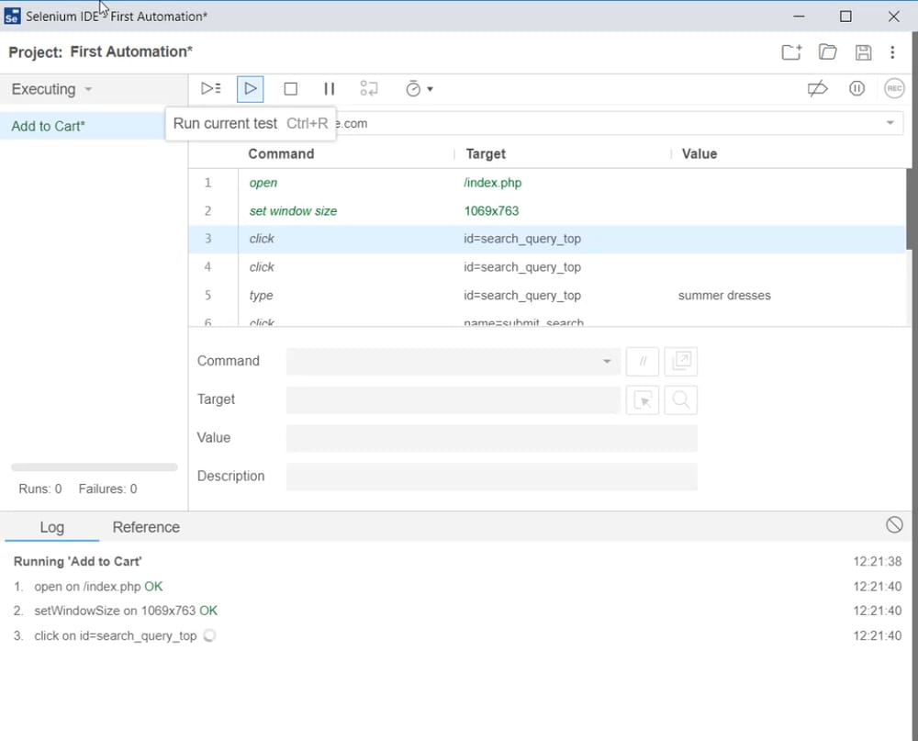Fig 6.4.1 : Selenium Testing performed on the system

**Chapter 7: Results and Discussion**

**7.1. Screenshots of User Interface (UI) for the respective module**

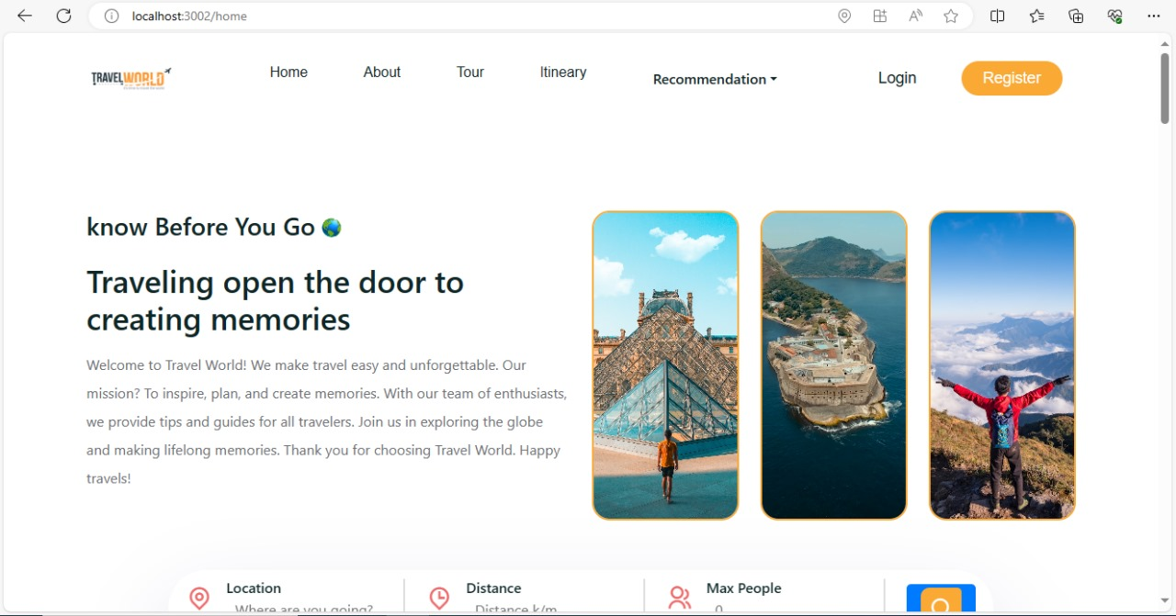

Fig 7.1.1 Home Page

The above figure shows the home page, where users can see a list of various tour packages, generate itinerary, recommendation, weather calculation and hotels and flight booking .

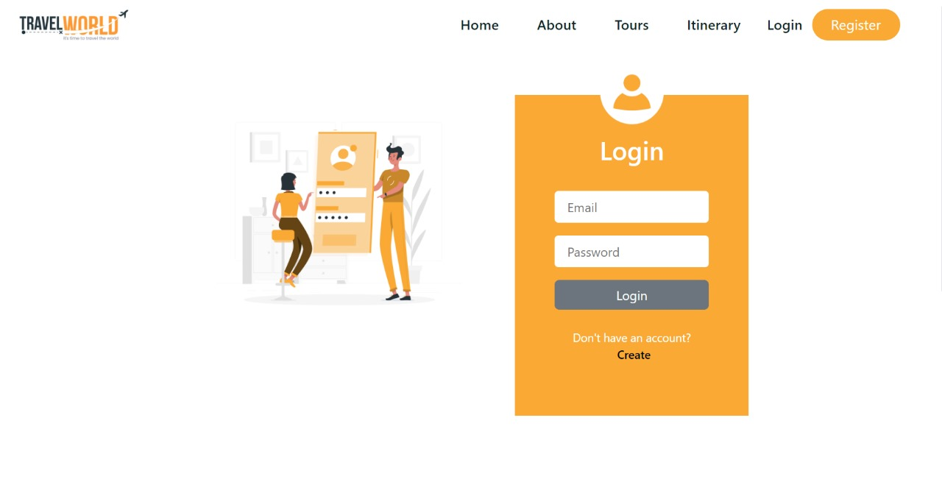

Fig 7.1.2 Login Page

The above figure shows the Login page where already registered users can directly login into the application by entering their username and password, in case the user is new then the create button will directly redirect to them at registration page.

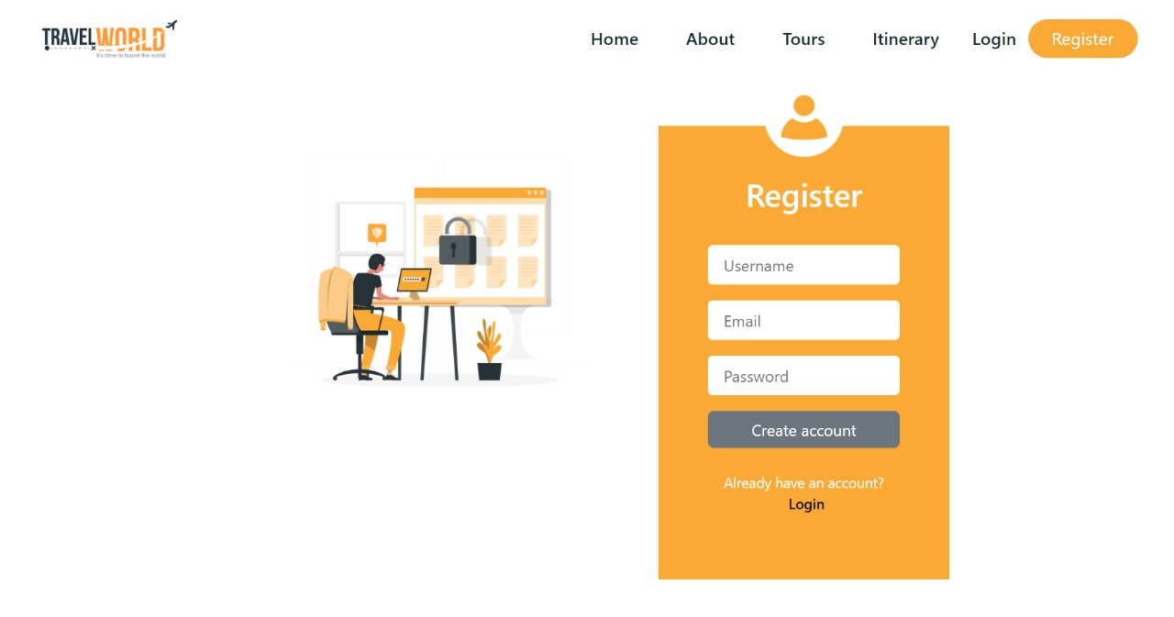

Fig 7.1.3. Registration Page

The above figure shows the registration page for new users where users can create their username and password which will be stored in our database.

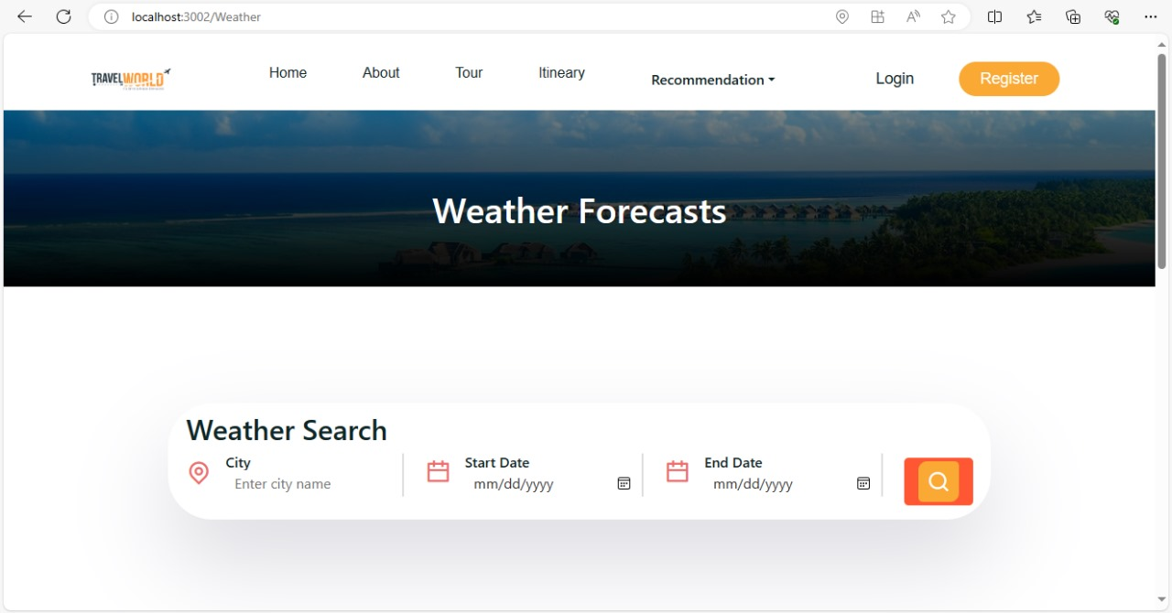

Fig 7.1.4. Weather Forecast

In this page the weather for the trip is shown, where the user should enter the city name, start date and end date of the trip, based on that the weather is shown.

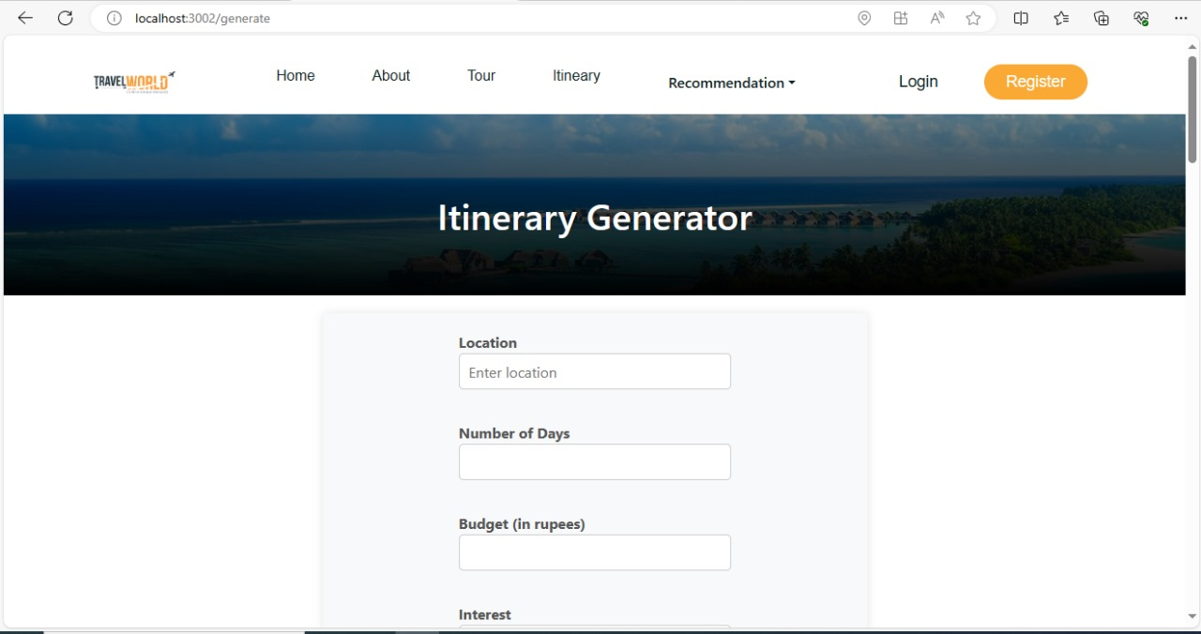

Fig 7.1.5. Itinerary Generator

In this page the user is expected to input the location, the number of days for the trip, interest, based on that the system generates the itinerary based on user input form.

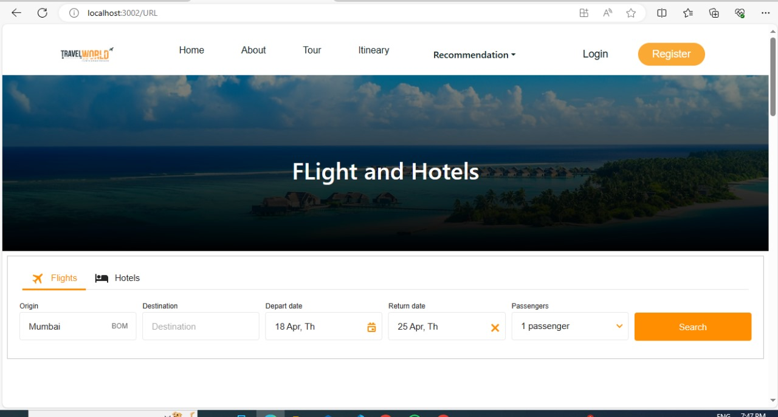Fig 7.1.6. Flight and Hotel Bookings

In this page the user is expected to enter source and destination, start date, end date and also the number of passengers so based on the input the user will be redirected to flights booking or hotels page.

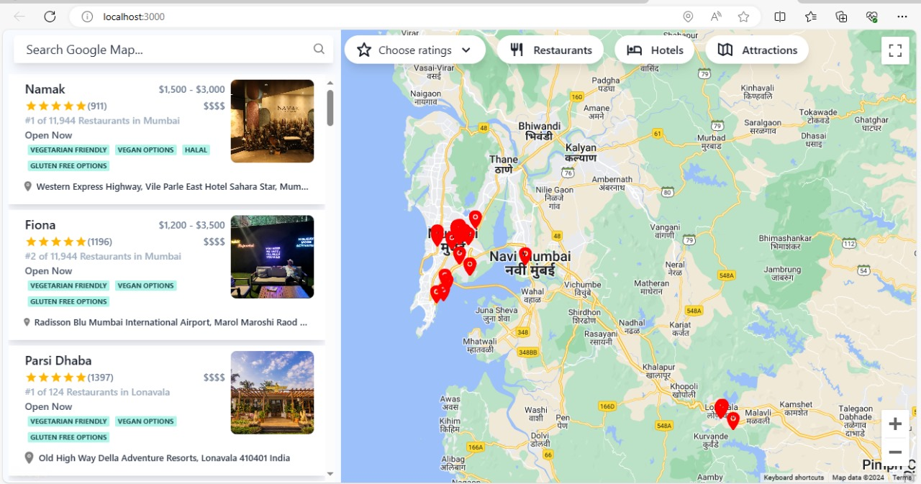

Fig 7.1.7. Recommendation System

In this page, based on the user's location the nearby restaurants, hotels, attractions are displayed and also the user can manually type the location or area.

**7.2. Performance Evaluation measures**

* Accuracy of Recommendations: The accuracy of recommendations is vital for enhancing user satisfaction and experience. We measure this by comparing the recommended restaurants, attractions, and hotels to user preferences and evaluating how well they align. A higher accuracy indicates that our system effectively understands user preferences and provides relevant recommendations, ultimately leading to improved user satisfaction.
* Efficiency of Itinerary Generation: Efficiency in itinerary generation is crucial for providing timely travel plans to users. We evaluate this by measuring the time taken for the system to generate a complete itinerary from user inputs. A faster generation time indicates higher efficiency, enabling users to receive their travel plans quickly and efficiently, thereby enhancing user convenience and engagement.
* Customization Flexibility: The flexibility of customization options allows users to tailor their itineraries according to their specific preferences and requirements. We assess this by examining the variety and depth of customization features available to users, such as adjusting travel dates, modifying itinerary components, and incorporating personalized recommendations. A higher level of customization flexibility indicates better adaptability to diverse user needs and preferences, contributing to enhanced user satisfaction and engagement.
* User Engagement Metrics: User engagement metrics, including user interaction with the platform, session duration, and repeat usage, reflect the platform's ability to captivate and retain users. We track metrics such as the number of itinerary revisions made by users, the average session duration, and the frequency of return visits. Higher user engagement metrics signify increased user interest and satisfaction with the platform, demonstrating its effectiveness in meeting user needs and preferences.
* Feedback and Reviews: User feedback and reviews provide valuable insights into the perceived usability, effectiveness, and overall satisfaction with the Smart Travel Itinerary platform. We collect and analyze user feedback through surveys, ratings, and reviews, focusing on aspects such as ease of use, usefulness of recommendations, and overall experience. Positive feedback and high ratings indicate successful implementation of the project's objectives and highlight areas for further improvement to ensure continued user satisfaction and engagement.

**7.3. Input Parameters / Features considered**

* User Preferences: Preferences provided by the user, such as destination, travel dates, budget, accommodation preferences (e.g., hotel vs. Airbnb), transportation preferences (e.g., car rental vs. public transport), and interests (e.g., nature, adventure, history).
* Travel Dates: Users input their desired travel dates to generate itineraries tailored to their availability.
* Budget: Users specify their budget constraints to ensure that recommended activities, accommodations, and dining options align with their financial preferences.
* Interests: Users provide information about their interests, such as outdoor activities, cultural experiences, or adventure sports, to personalize their travel recommendations.
* Destination Preferences: Users indicate their preferred destinations or regions they wish to explore during their trip.

**7.4. Inference drawn**

Based on the results obtained and discussions conducted, several inferences can be drawn regarding the effectiveness and performance of the Smart Travel Itinerary Project:

* The project effectively delivers personalized travel itineraries and recommendations to users, significantly improving their travel planning experience and overall satisfaction.
* Users find the interface intuitive and user-friendly, making it easy to input their preferences and customize their travel plans according to their needs.
* Integration of real-time data sources, such as location-based services for nearby resources and weather prediction APIs, ensures that users receive accurate and up-to-date information for their travel destinations.
* The project demonstrates superior performance compared to traditional travel planning methods, offering more comprehensive and tailored recommendations while streamlining the itinerary generation process.

**Chapter 8: Conclusion**

**8.1 Limitations**

Despite the strengths and capabilities of our Smart Travel Itinerary project, several limitations should be acknowledged:

* Dependency on Data Sources: The accuracy and reliability of itinerary recommendations heavily rely on the quality and availability of external data sources, such as weather forecasts, nearby resources, and booking platforms. Any inaccuracies or limitations in these data sources may impact the quality of recommendations provided to users.
* Algorithmic Limitations: While our AI-driven itinerary generation algorithm aims to provide personalized recommendations, it may not always fully capture the diverse preferences and constraints of all users. The algorithm's effectiveness may vary depending on the complexity and variability of user preferences, leading to suboptimal recommendations in certain scenarios.
* Technological Constraints: The application's performance, scalability, and functionality may be constrained by limitations in technology infrastructure, including server capabilities, network bandwidth, and computational resources. Addressing these constraints may require additional investments in infrastructure and technology upgrades.

**8.2 Conclusion**

Smart Travel Itinerary project represents a significant advancement in modernizing travel planning. Through the integration of AI-driven algorithms and user-centered design principles, we've aimed to deliver a platform that caters to the diverse needs and preferences of travelers. By prioritizing meticulous requirement gathering and rigorous testing, we've strived to ensure the application's functionality, usability, and security meet the highest standards.

While our project boasts numerous strengths, it's essential to recognize its limitations. Dependencies on external data sources, potential algorithmic constraints, and security vulnerabilities are among the challenges we've addressed. However, by acknowledging these limitations and continuously refining our approach, we're committed to enhancing the application's value proposition and ensuring a seamless user experience.

In conclusion, our Smart Travel Itinerary project is poised to revolutionize the way travelers plan and experience their journeys. With a relentless focus on innovation, user feedback, and excellence, we're confident that our platform will not only streamline the travel planning process but also redefine expectations for personalized, efficient, and enjoyable travel experiences in the digital age.

**8.3 Future Scope**

Looking ahead, there are several avenues for future work and enhancement of our Smart Travel Itinerary project. Firstly, we aim to further refine the AI-driven algorithms powering itinerary generation and recommendation systems. By incorporating advanced machine learning techniques and leveraging vast datasets, we can improve the accuracy, personalization, and adaptability of itinerary recommendations to better meet individual traveler preferences and evolving travel trends.

Secondly, expanding the application's coverage and integration with additional data sources and services can significantly enhance its utility and value proposition. This includes integrating real-time updates on travel conditions, events, and attractions, as well as forging partnerships with booking platforms, transportation providers, and local businesses. By offering a comprehensive and seamless travel planning experience, we can better cater to the diverse needs and interests of travelers worldwide.

Lastly, we recognize the importance of ongoing innovation and adaptation to emerging technologies and industry trends. Embracing developments in augmented reality (AR), virtual reality (VR), and blockchain technology can unlock new possibilities for enhancing the user experience, facilitating secure transactions, and providing immersive travel previews. By staying at the forefront of technological advancements and continuously iterating based on user feedback, we can ensure our Smart Travel Itinerary project remains at the forefront of the travel industry for years to come.

**References**

[1] Guochen Cai, Kyungmi Lee, Ickjai Lee (2018) “Itinerary recommender system with semantic trajectory pattern mining from geo-taggedphotos” IEEE Trans Intell Transp System.

[2] Tarun Surender Reddy, Jenila Rakesh Sanghvi, Deval Paresh Vora, Pratik Kanani (2017) “Wanderlust : A Personalised Travel Itinerary Recommender” IEEE Fourth International Conference on Big Data Computing Service and Applications.

[3] Mrs. S. Sangeetha Mariammal , S B Akshaya , M Priyanga, S Saran Kumar,P Prakash (2019) “ Smart Travel ItineraryPlanner” Springer.

[4] Alessandra Paola, Gaglio, De Salvatore Andrea Giammanco, Giuseppe Lo Re, Marco Morana (2021) " A multi-agent system for itinerary suggestion in smart environments" Springer.

[5] Hoon-cheol Kang1, Myeong-Cheol Jeong-Woo Jwa (2020),“The task-oriented Smart Tourism Chatbot Service“ Springer.

**Appendix**

1. **Research Paper Details**
2. **Paper published**

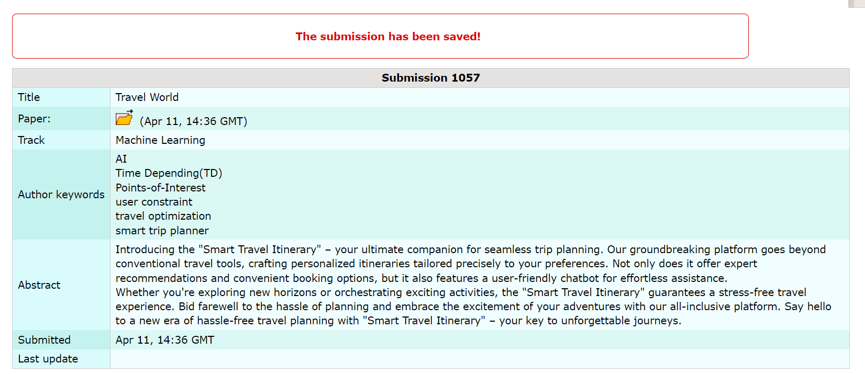



**b. Plagiarism report**

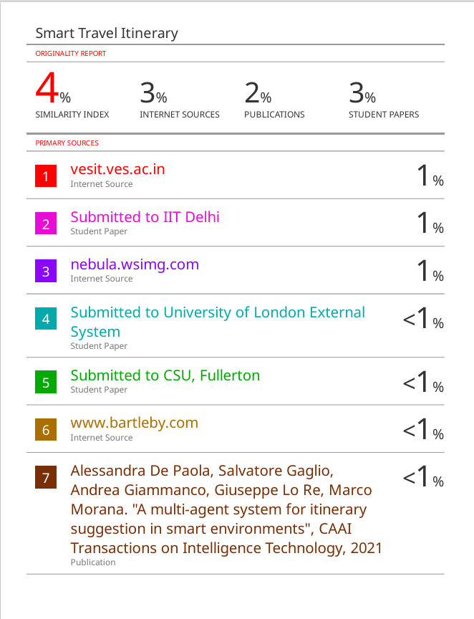

**d. Review Sheet**

Review1

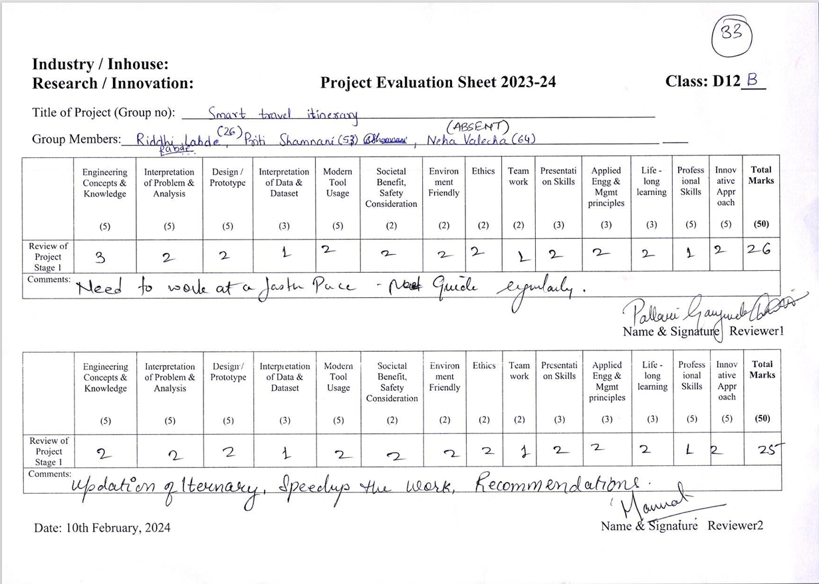

Review 2

